Paper Title (use style: paper title)

Presenting Author Name¹, Author Name¹, Author Name^{2,*}

¹Replace this sentence by typing the affiliation information of the Author "a" keeping the font type and size
²Replace this sentence by typing the affiliation information of the Author "b" keeping the font type and size
* Corresponding author: phone number and e-mail
____________________________________________________________________________

ABSTRACT

Use this abstract template to fill out the information. Please keep page format, do not change font size or type. The title must be concise and informative, with no more than two lines. The authors should be listed using the author´s first name initial followed by last name(s). Other authors should be separated with a semicolon. Presenting and the corresponding author should be underlined and marked with an asterisk, respectively. Authors must be linked to their affiliation with a lower-case superscript letter. The affiliation must include the institution name, complete address, zip code, and country.

The abstract body should be informative, concisely stating the subject, giving a clear indication of the nature of the problem under investigation. It should indicate the methods and main results, and at the end, a brief conclusion. The abstract should not include figures, tables, or references. Total abstract content should have between 250 to 350 words. After the abstract body, include four keywords related to the subject.

Keywords: component; formatting; style; styling

____________________________________________________________________________

1. Introduction

Write the introduction text here. Please write in American English or British English, but not a mixture of them. If it is required, ask for a manuscript revision by a native English speaker. Use this template to add the information of each section of your entire paper. Please, do not change the font size and type, and in general, all the page format. It is important to adhere to the template format in order to speed up the review and approval process. The full paper should be at least five pages long and should not exceed ten pages, including all sections. Authors have the option to include as many sections as they wish; however, it is highly recommended to include the essential elements required to convey your manuscript, for example, Abstract, Keywords, Introduction, Materials and Methods, Results, Conclusion, and References. The references should be numbered and included at the end of the paper in consecutive order in which they appear [1].
The introduction section should give a clear idea of the problem to be addressed, the research background. Include previously publish references pertinent to work, accenting the major original contributions, possible application areas, etc. Give a brief description of the manuscript.
Subsections should be numbered 1.1 (then 1.1.1, 1.1.2 ...), 1.2, etc. Sub-section headings should be in italic letters, numbered and left-justified; capitalize the first letter.

2. Materials and Methods

Provide sufficient detail to allow the work to be reproduced. Methods already published should be indicated by a reference; only relevant modifications should be described. It is advisable to include subsections, especially if a number of methodologies are included.
If a theory/calculation subsection is included, it should provide all the information relevant to be reproduced.

3. Results and Discussion

Results should be clear and concise, avoid verbosity and repeated results. Please ensure Figures and Tables are placed next to the respective text in the manuscript, rather than at the bottom or the top of the file. Ensure that each illustration and table has a caption. A caption should comprise a brief title (not on the figure itself) and a description of the item. Keep minimal text in the illustrations but explain all symbols and abbreviations used.
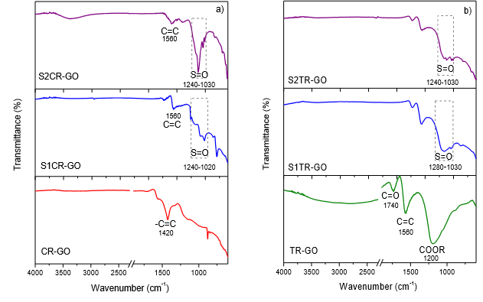
Fig. 1. Figure and figure caption should be centered. JPEG and GIF formats are accepted. A minimum of 300 dpi is encouraged. (a) Intensity of atomic forces; (b) Translocation of lithium atoms in the material; (c) Effect of chain substituents on the intensity of atomic forces.
Make sure to include the corresponding units in the SI. Color in figures is allowed. Use a maximum of five figures and five tables. Be sparing in the use of tables, and ensure that the data presented in them do not duplicate results described elsewhere in the article, for example, in another figure.

Table 1. Tables should be inserted as editable text in Word and not as images.
Sample | ECSA H_{upd} (cm² _{Pt}) | Time  (s) | ECSA* (m² g⁻¹ _{Pt})
S1 | 9.9 | 20 | 20.6
S2 | 4.4 | 40 | 10
S3 | 3.4 | 60 | 7.5

Add Math equations as editable text, not as images. Present simple formulae in line with normal text where is possible and use the solidus (/) instead of a horizontal line for small fractional terms, e.g., X/Y. In principle, variables are to be presented in italics. Number consecutively any equations that have to be displayed separately from the text (if referred to explicitly in the text).

(1)

4. Conclusion

Present a brief conclusion of the main results of your research. Avoid discussions of the obtained data. If it is necessary, then include a discussion section placed before the conclusions.

Acknowledgments

Provide the funding information for your research. Furthermore, if you receive any fellowship from the SMH and XXI International Congress of the Mexican Hydrogen Society, provide the corresponding acknowledgment.

References

The reference format should be as the provided examples. If a specific reference format is not included, please visit the Guide for Authors of the International Journal of Hydrogen Energy, Elsevier.

[1] Van der Geer J, Hanraads JAJ, Lupton RA. The art of writing a scientific article. J Sci Commun 2010;163:51–9.
[2] Strunk Jr W, White EB. The elements of style. 4th ed. New York: Longman; 2000.
[3] Mettam GR, Adams LB. How to prepare an electronic version of your article. In: Jones BS, Smith RZ, editors. Introduction to the electronic age, New York: E-Publishing Inc; 2009, p. 281–304.
[4] Cancer Research UK. Cancer statistics reports for the UK, http://www.cancerresearchuk.org/
aboutcancer/statistics/cancerstatsreport/; 2003 [accessed 13.03.03]

